**Assignment 11**

1. **Write a query that uses a subquery to obtain all orders for the customer named Cisneros. Assume you do not know his customer number (cnum).**

**Select Onum from orders where Cnum=(select Cnum from customers where Cname=’Cisneros’);**

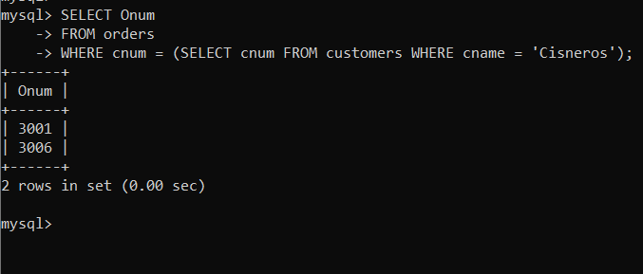

1. **Write a query that produces the names and ratings of all customers who have above-average orders.**

**Select Cname,rating from customers where Cnum in(select Cnum from orders where amt> (select avg(amt)from orders));**

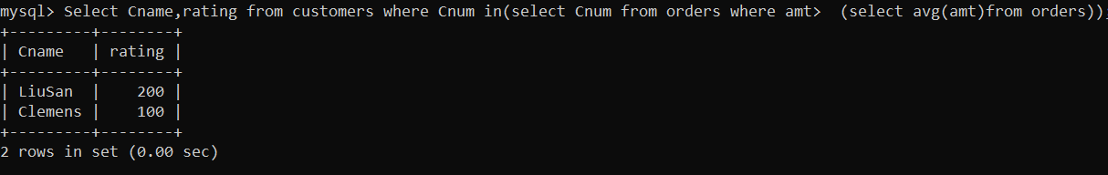

1. **Write a query that selects the total amount in orders for each salesperson for whom this total is greater than the amount of the largest order in the table.**

**Select sum(Amt) from orders group by Snum having sum( Amt)>(Select max(Amt)from orders);**

